Unit 8: Quadratics

Lesson 2: Solving Quadratics by Factoring

Objectives:

* I can solve quadratics by factoring.
* I can use the zero product property to justify work when solving quadratics
* I can explore quadratics in real life.

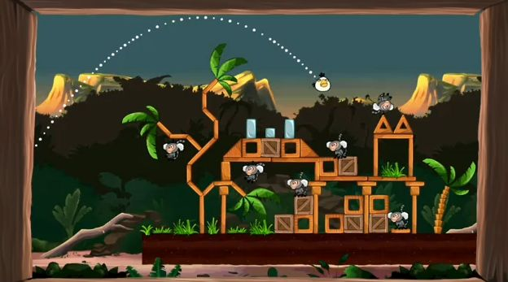

Agenda:

* Video
* Practice
* Application

Focus Questions:

* How do we solve quadratics using factoring?
* What is the connection between the factors and the zeros of a quadratic?

Vocabulary:

* Quadratic, Parabola, zero property, factor, zeros, vertex

Homework: HW8-2

Online support:

* <https://www.youtube.com/watch?v=IKyUuvulIbk>
* <https://www.youtube.com/watch?v=g6RnAY_VkMs>

[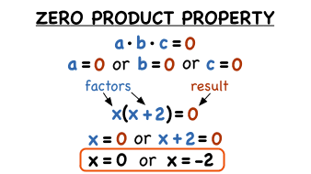](http://www.google.com/url?sa=i&rct=j&q=&esrc=s&source=imgres&cd=&cad=rja&uact=8&ved=0ahUKEwjZ_pz-iefZAhVjmeAKHVS8C9MQjRwIBg&url=http://virtualnerd.com/algebra-1/polynomials-and-factoring/factoring-strategy-solving-equations/solving-equations/zero-product-property-definition&psig=AOvVaw3D7aH3FkDIXfWrcNt2JaGw&ust=1520954179703657)**The Zero Product Property states that if ab = 0, then either a = 0 or b = 0, or both a and b are 0. When the product of factors equals zero, one or more of the factors must also equal zero. Once the polynomial is factored, set each factor equal to zero and solve them separately.**

Do Now: Factoring Feb

$A) 49x^{2}-100$ B) $-3x^{3}-21x$

C) ${ 64x}^{2}-9$ D) ${9x}^{2}-16$

E)

Find the axis of symmetry algebraically:

$E) y=x^{2}-36$ $F) y=x^{2}-5x+6$

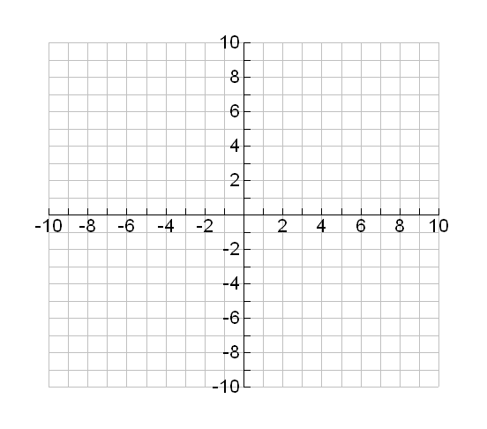2) For the following function $f(x)=-x^{2}+4x+5$

|  |  |
| --- | --- |
| x | F(x) |
|  |  |
|  |  |
|  |  |
|  |  |
|  |  |

1. Graph the function.
2. Identify the vertex: max or min
3. Identify the y-intercept:
4. Identify the roots:
5. Identify the domain and range:

**Lesson 8-2: Notes: Use the zero product property to solve the following equations:**

Factor and use the zero product property to find the solutions for x:

1. 2. 3.

**Factor first then solve for the x–intercepts (roots, zeroes)**

|  |  |  |
| --- | --- | --- |
| 1 $x^{2}+8x+15=0$ |  | $20x^{2}-10x=0$ |
| $4. 3x^{2}+5x=2$ | $$5. 4x^{2}-16x-84=0$$ | $$6. 49x^{2}-100=0$$ |
| ${7. -4x}^{3}+12x^{2}=0$ | $${ 8. 64x}^{2}-9=0$$ | 9. |

**Name: ___________ Homework 8-2**

**Factor first and use the Zero product law to find the solutions.**

1 2.

3. 4) 

5. 6. 

7. 8.

1. The length of a rectangle is 4 less than twice the width. The area of the rectangle is 70. Find the dimensions of the rectangle.
2. Write an equation that can be used to find the dimensions of the window?
3. Solve algebraically by factoring.

**Extra practice:**

1. The length of a rectangular window is 5 feet more than its width, w. The area of the window is 36 square feet.
2. Write an equation that can be used to find the dimensions of the window?
3. Find the dimensions of the window algebraically.
4. A landscaper is creating a rectangular flower bed such that the length is five more than the width. The area of the flower bed is 36 ${ft}^{2}$.
5. Write and solve an equation to determine the width of the flower bed in feet.
6. Find the length in feet

10. 11. 12.

13. 14. 15.